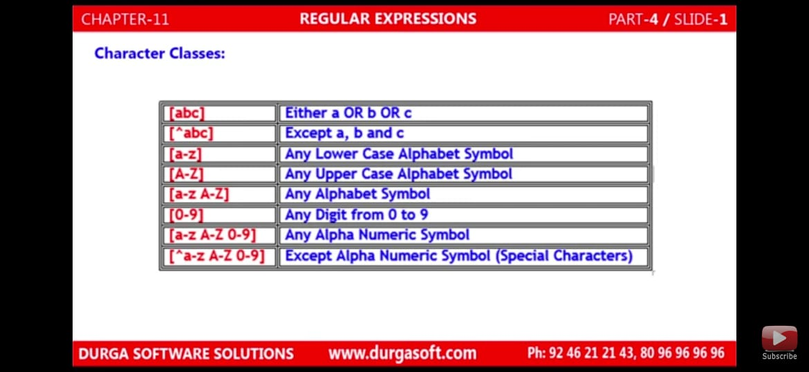
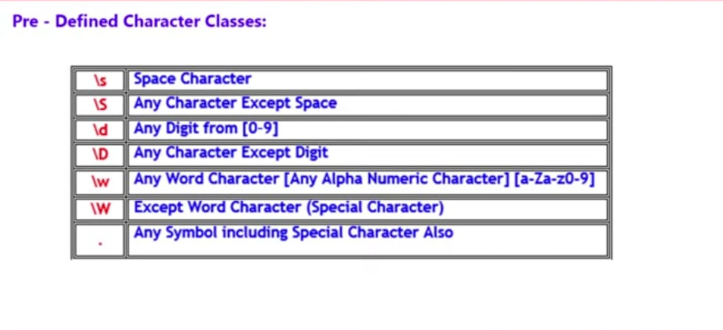
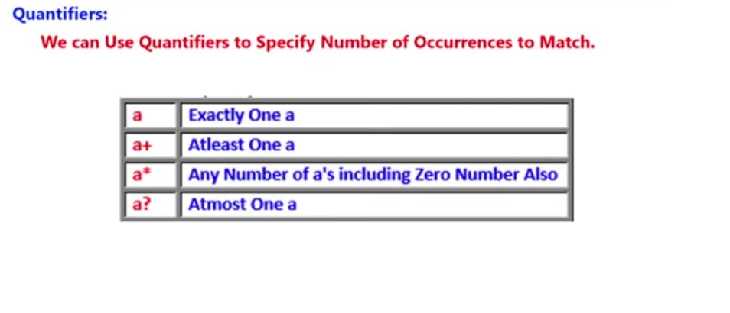

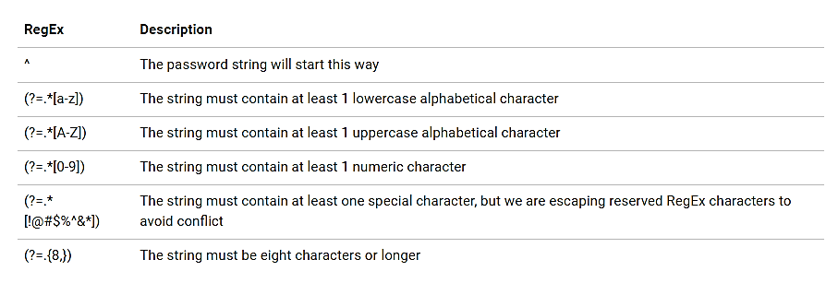
let onlyPwd = /^(((?=.*[a-z])(?=.*[A-Z]))|((?=.*[a-z])(?=.*[0-9]))|((?=.*[A-Z])(?=.*[0-9])))(?=.{6,})/

Metacharacters.
Metacharacters are characters that are interpreted in a special way by a RegEx engine. Here's a list of metacharacters:
[] . ^ $ * + ? {} () \ |
[] : Square brackets specify a set of characters you wish to match.
[a-e] is the same as [abcde].
[1-4] is the same as [1234].
[^abc] means any character except a or b or c.
[^0-9] means any non-digit character.

. - Period
A period matches any single character (except newline '\n').
^ - Caret
The caret symbol ^ is used to check if a string starts with a certain character.
^a : a [macth]/ abc [match] /bcs [no match]
^ab : [starts with a and followed by b]
: abc [match] / acb[no match]

$ - Dollar
The dollar symbol $ is used to check if a string ends with a certain character.
a$ : aga[match] / Asha[match]/ royal[no match]

* - Star
The star symbol * matches zero or more occurrences of the pattern left to it.
ma*n : mn[match]/man[match]/main[no match (n is not ritght after a)]

+ - Plus
The plus symbol + matches one or more occurrences of the pattern left to it.
ma*n : mn[ no match(a is missing)]/man[match]/main[no match (n is not right after a)] /woman[match]
? - Question Mark
The question mark symbol? Matches zero or one occurrence of the pattern left to it.
Sa?n : san[match]/saan[no match (a accure more than one time)]

{} - Braces
Consider this code: {n,m}. This means at least n, and at most m repetitions of the pattern left to it.
a{8,32 } : aa [match]/ maaan [match]/ can [no match (at least two times need to present)]
a{6}: fix only two times
| - Alternation
Vertical bar | is used for alternation (or operator).
a|b : matches string that contains a or b in them

() - Group
Parentheses () is used to group sub-patterns. For example, (a|b|c)xz match any string that matches either a or b or c followed by xz
\ - Backslash
Backslash \ is used to escape various characters including all metacharacters. For example,
\$a match if a string contains $ followed by a. Here, $ is not interpreted by a RegEx engine in a special way.
If you are unsure if a character has special meaning or not, you can put \ in front of it. This makes sure the character is not treated in a special way.
Individual :
Minimum eight characters, at least one letter and one number:
"^(?=.*[A-Za-z])(?=.*\d)[A-Za-z\d]{8,}$"

Minimum eight characters, at least one letter, one number and one special character:
"^(?=.*[A-Za-z])(?=.*\d)(?=.*[@$!%*#?&])[A-Za-z\d@$!%*#?&]{8,}$"

Minimum eight characters, at least one uppercase letter, one lowercase letter and one number:
"^(?=.*[a-z])(?=.*[A-Z])(?=.*\d)[a-zA-Z\d]{8,}$"

Minimum eight characters, at least one uppercase letter, one lowercase letter, one number and one special character:
"^(?=.*[a-z])(?=.*[A-Z])(?=.*\d)(?=.*[@$!%*?&])[A-Za-z\d@$!%*?&]{8,}$"

Minimum eight and maximum 10 characters, at least one uppercase letter, one lowercase letter, one number and one special character:
"^(?=.*[a-z])(?=.*[A-Z])(?=.*\d)(?=.*[@$!%*?&])[A-Za-z\d@$!%*?&]{8,10}$"

